LinkAssistant

LinkAssistant helps you manage your link building the easiest and most effective way
LinkAssistant is a powerful cross-platform link building and management tool. It lets you unearth valuable link sources, manage your new and existing links, automate each stage of your link building campaign where possible - and more. The software takes care of the tedious and time-consuming link building tasks and impressively cuts boring and monotonous link building workload.
Here is a brief list of the benefits LinkAssistant is offering you:
- Build high-quality links, safe for Google updates
- Conveniently manage your link outreach
- Monitor all your current backlinks
- Control link profile growth over time
- Create reports on link building activities
Let's take a closer look at LinkAssistant's features.

Find potential link sources
LinkAssistant offers easy ways to find a great number of juicy link sources using various search mechanisms:
- Find sites by keyword search
- Find sites that link to your competitors
- Find sites that already link to you
- Harvest all URLs on webpages you specify
- Perform a deep scan on the website you specify
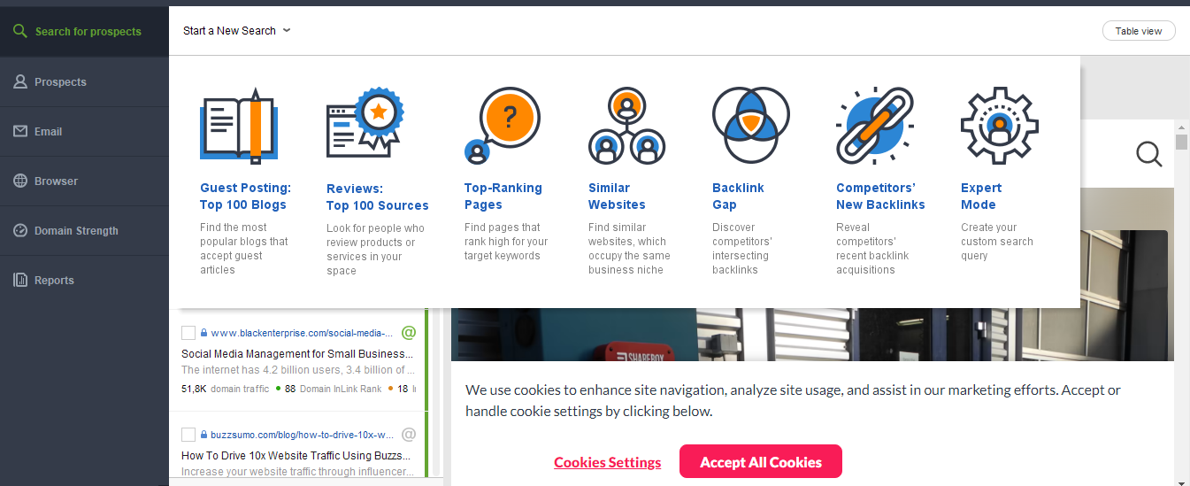

Check the value and quality of each potential link
Each found link is analyzed according to various SEO important factors, which lets you surface the best sources to build links - and avoid harmful links that make cause a penalty from Google. Here are some of the factors LinkAssistant will check for you:
- Google PageRank of the domain
- Google PageRank of the page
- Page Popularity on Facebook, Twitter, LinkedIn etc.
- Domain Age
- Domain's IP address and country
- Number of outgoing links
- Total number of links
- and more
Also LinkAssistant lets you organize your link sources into categories, assign them various statuses and sort them out to conveniently review your link sources.

Get in touch with link prospects
LinkAssistant finds contact info of website owners, webmasters etc. and lets you quicken the process of contacting these people to discuss potential link placement.
The software offers editable email templates that you can use repeatedly and personalize as you feel necessary. The software offers a built-in email client that lets you keep all your messaging inside LinkAssistant.
As you reach out to other sitesí owners, all your correspondence is stored inside the software, and you can re-check all your agreements or see when itís best to follow up on the previous message, etc.
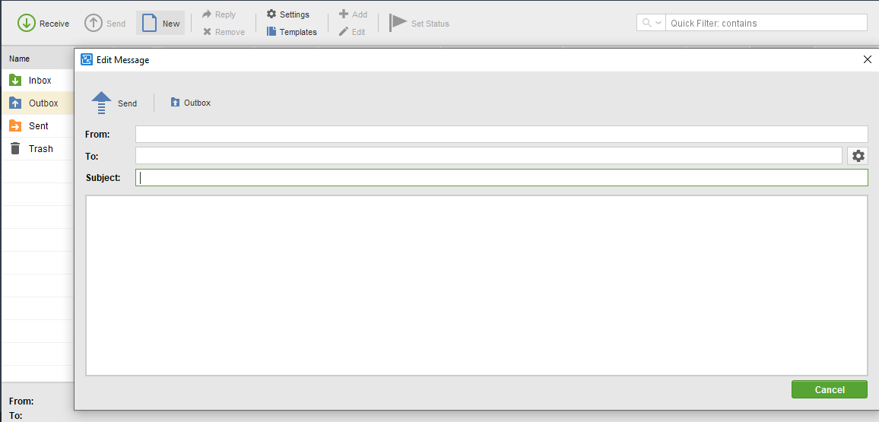

Verify links to make sure they haven't changed their value over time
As your link profile keeps growing, you will want to keep an eye on the links you've built - and check that the backlinks are in place, have the right anchor text, haven't got a Nofollow tag etc.
To check on the links you've built, you have a special Verify button in LinkAssistant. One click on this button lets you run a quick check and see what changes happened to your old links.
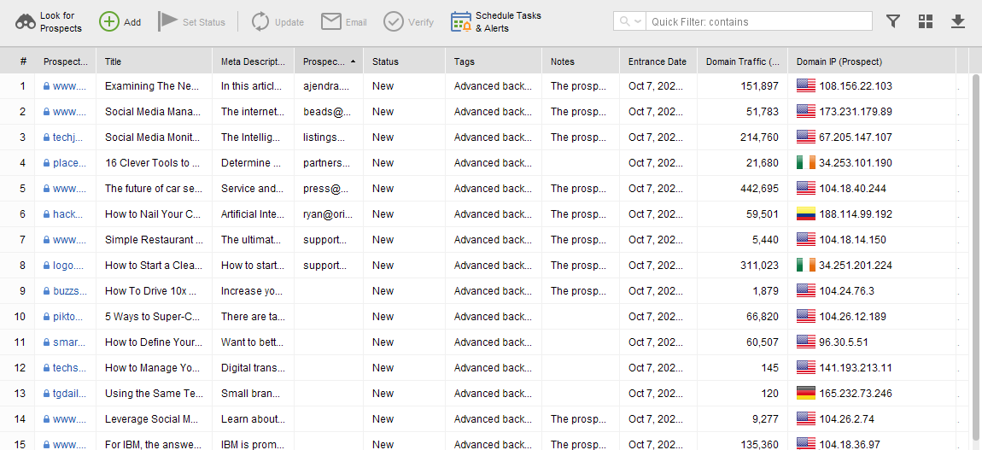

Customizable reports in HTML and PDF
And finally LinkAssistant lets you build excellent link-building reports in PDF or HTML format. Just like the rest of SEO PowerSuite tools, LinkAssistant features a drag-n-drop report editor which makes it easy for you to choose which data sections to include in the report and how to order them.
You can customize pretty much everything in LinkAssistant's reports: change reports' color schemes, language, add your own or your customers logo, fill in your firm's or your clients requisites etc. You can simply print a report, or save it as a PDF/HTML file and, if needed, upload it to the web or send to email, straight from the software.
If instead of saving PDF reports, you prefer to export all the data "as is" and work with it outside LinkAssistant (ex. in an Excel spreadsheet), you can export your data in various supported formats (.csv,. xml, .sql, .txt).

Bottom line
LinkAssistant is an excellent link management tool. In the times when you've got to work cafefully on getting each link in place, it's a great help. LinkAssistant helps you speed up the tasks that can be done faster, and it looks seriously at verifying your backlinks for any issues undermining their SEO quality.
The price for LinkAssistant varies as the developer offers it in three editions: Free (with certain limitations), Professional and Enterprise. You can purchase LinkAssistant as one tool, or as part of the all-in-one SEO PowerSuite toolkit which also includes the tools for rank checking, keyword research, link search and on-page SEO. You will find LinkAssistant pricing here.
You should check out how this most effective and simple link building tool can boost your website's link popularity.
Download your free copy of LinkAssistant!

