Rank Tracker

Rank Tracker - rankings monitoring and keyword research tool
A crucial part of any SEO campaign is the ongoing assessment of a website's ranking performance for the selected keywords. Measuring website ranking fluctuations makes SEO monitoring (and reporting) more efficient, lets you streamline SEO workflows and tailor the most effective optimization strategy for the targeted niche.
Another important part of any SEO strategy is keyword research. One needs to find keywords that have the right balance of search volume, relevancy and competition. Such keywords let you draw in more visitors and convert them after they arrive.

Have your rankings checked on the fly
Rank Tracker is a powerful rank checking tool that lets you:
- monitor your website organic rankings in over 400 international and local search engines;
- monitor your competitors' rankings and compare them to yours;
- monitor your and your competitors rankings in Google universal search result blocks: images, videos, news, shopping, places, books and realtime results;
- set location to get rankings data for geo-targeted search;
- locate all pages of your site ranking for one and the same keyword;
- analyze side by side your rankings and Google Analytics traffic data;
- monitor rankings on auto-pilot;
- work on keyword mapping;
- automatically keep track of your rankings history;
- generate professional-looking and eye-candy SEO reports.
Rankings monitoring is very easy when you've got Rank Tracker. Here are some screenshots from the tool:
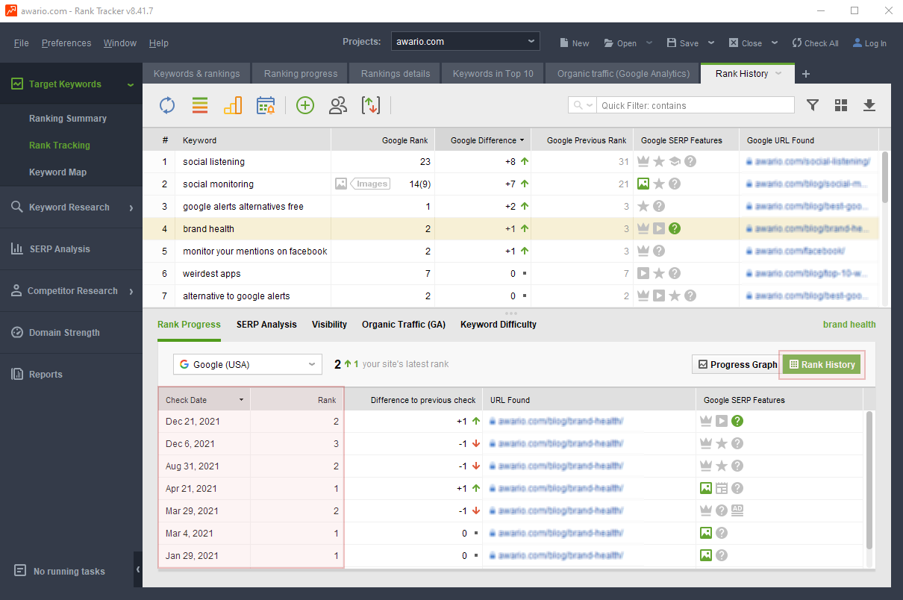
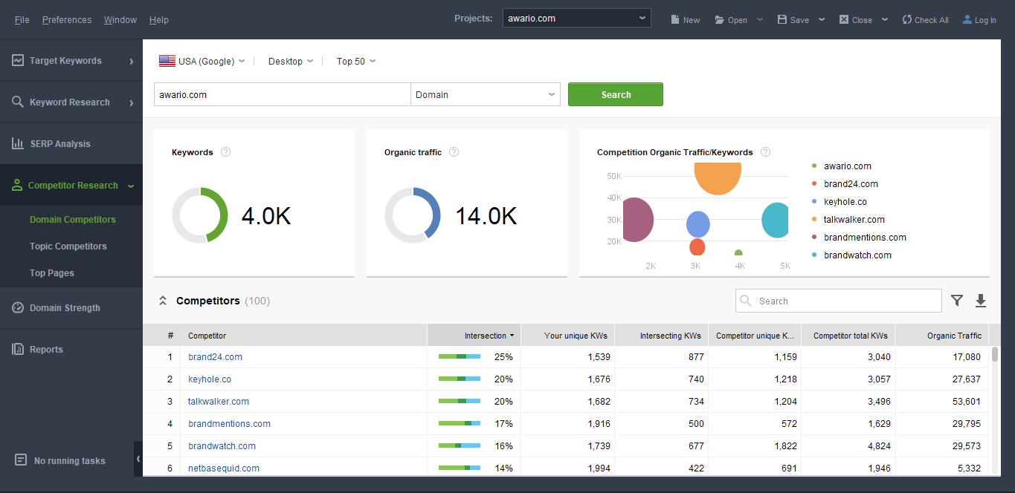

Traffic-generating keywords for your SEO campaign
Rank Tracker lets you explore new traffic opportunities and considerably expand the list of your website keywords. Equipped with 17 keyword research mechanisms, the software lets you find the most traffic-generating niche keywords.
The app also checks each keyword's search volume, evaluates the competition and calculates Keyword Efficiency Index (KEI).
On top of that, Rank Tracker fetches traffic data straight from Google Analytics. The tool checks the bounce rates and the number of actual visitors brought to your website by each keyword.
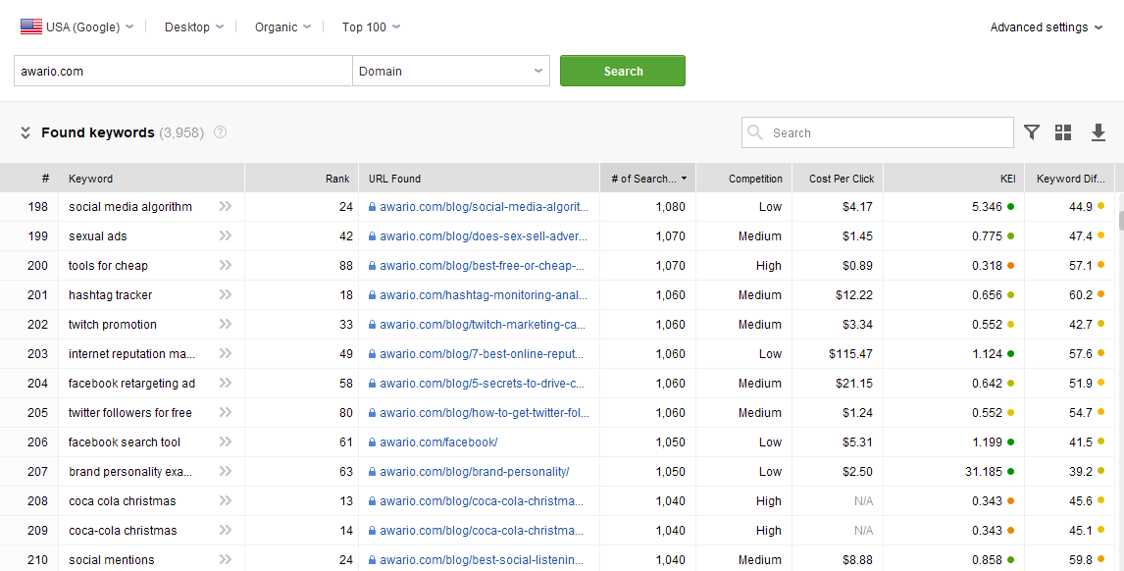
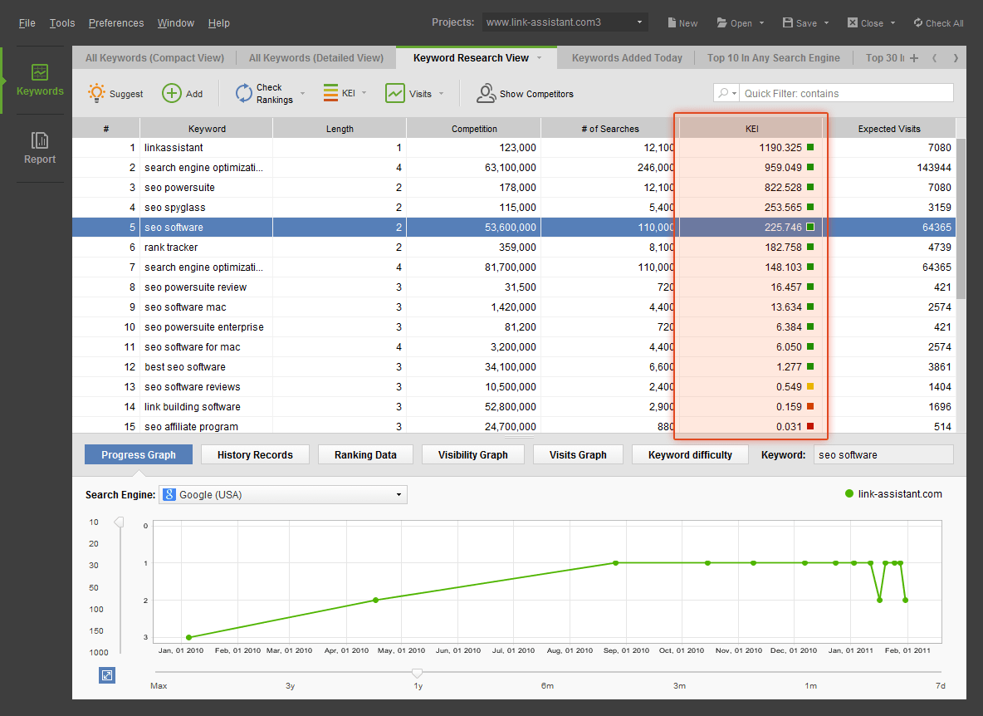

Wall-to-wall rankings and traffic reporting
Rank Tracker also has outstanding reporting facilities on board. The intuitive reporting area with a drag-n-drop report editor lets you generate various kinds of professional-looking eye-candy rankings and traffic reports. All reports are fully customizable: you can choose which data to include to build the report that suits your needs. You can also customize how the report looks: you can include your logo, change color scheme, add your client details, your contact details and more.
You can upload reports to your website or email them directly to your clients or colleagues. Also you can save them as PDF or HTML files or just print them out.
Moreover, you can export all the collected data in CSV, TXT, HTML, XML, SQL formats.

Bottom line
Rank Tracker is fast and feature rich - and it's a deal when it comes to the price. It’s a robust and precise tool in determining a website's rankings. Besides, Rank Tracker offers impressive ease of use and flexibility in organizing and filtering data.
The software comes as a separate tool in three editions, Free (limited features), Professional and Enterprise. You can check the pricing over here.
You can also have Rank Tracker as part of the SEO PowerSuite toolkit (which also includes link research, link management and onpage SEO tools).
Download a free copy of Rank Tracker now and get a real taste for the tool's capabilities!

