SEO PowerSuite Review
SEO PowerSuite is an effective one-stop SEO solution. This set of four SEO tools covers a wide range of on-page and off-page optimization tasks, including:
- keyword research;
- rankings monitoring;
- content optimization;
- SEO site audit;
- competition research;
- link building and management;
- ...and a lot more
With this full-cycle SEO software you can automate SEO routines, cut boring SEO workload and streamline your SEO efforts.
SEO PowerSuite toolkit includes the following tools that can be downloaded as one archive:
- Rank Tracker - the keyword research and rankings monitoring tool
- WebSite Auditor - on-page SEO and content optimization software
- SEO SpyGlass - backlink finder with powerful link quality assessment
- LinkAssistant - convenient tool for link management and link building

Let's look at the SEO PowerSuite tools one by one:

Rank Tracker is a rank checker and keyword research tool
Rank Tracker is an advanced rank monitoring tool that gathers a concise report of the ups and downs of your website's ranking. The app lets you:
- monitor your site rankings performance in over 400 international and local search engines;
- receive automatic suggestions of top ranking competitors;
- monitor your competitors' rankings and compare them to yours;
- monitor your and your competitors' rankings in Google and Bing universal search result blocks: videos, images, news, shopping, places, etc.;
- set any location to collect rankings data for (geo-targeted search);
- keep rankings history of each and every keyword;
- monitor rankings on auto-pilot;
- work on keyword mapping;
- get hundreds of keyword ideas with quality, traffic, and PPC analytics;
- and more

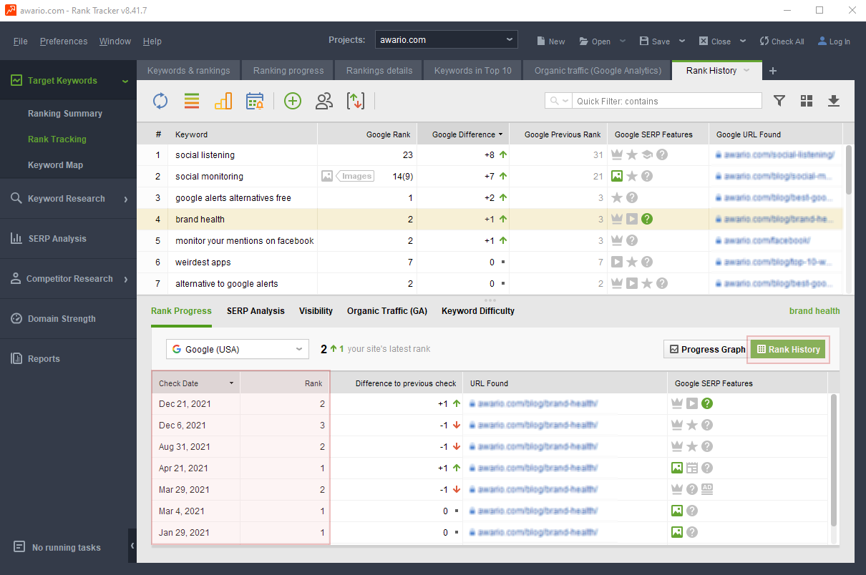
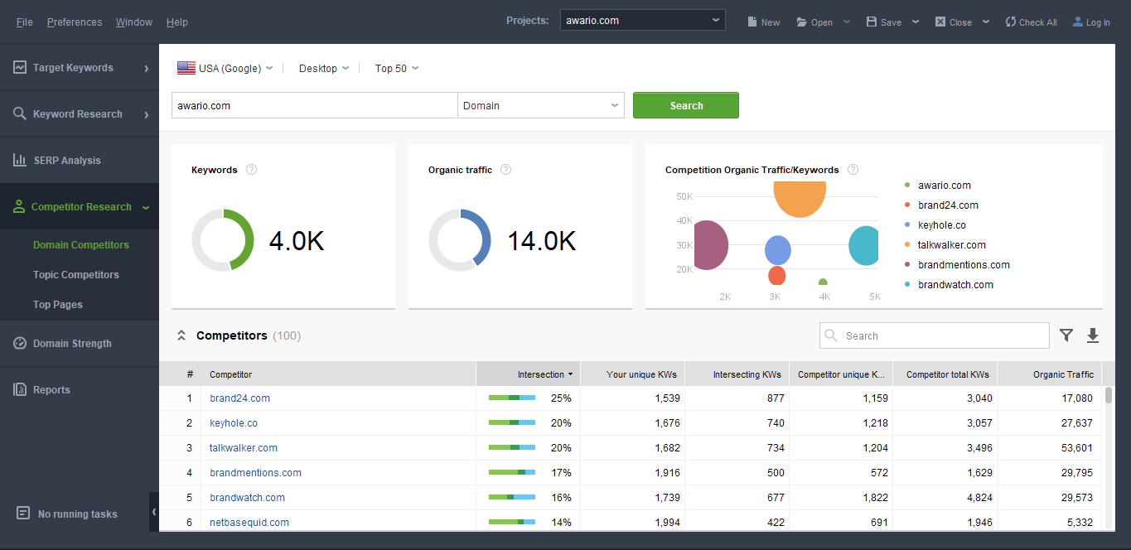
Equipped with 17 keyword research mechanisms, Rank Tracker lets you find a great number of keywords to optimize your website for. Each keyword is analyzed against KEI (Keyword Efficiency Index) - the most reliable criteria to identify how SEO-lucrative a keyword is.

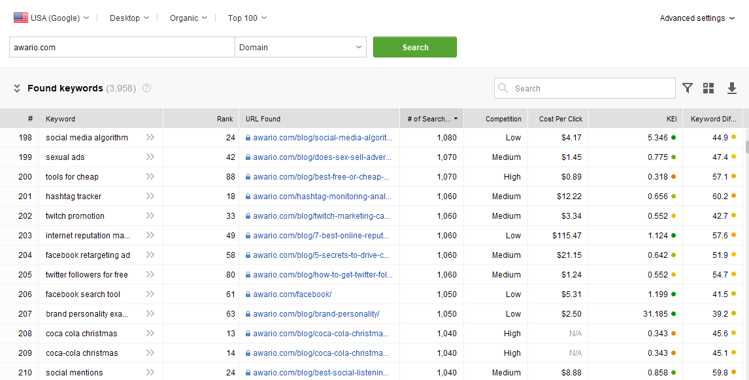
The software also provides you with valuable traffic stats from Google Analytics. With the tools you will learn:
- the number of visitors your keywords are driving;
- bounce rates for each keyword.
On top of that, Rank Tracker lets you analyze PPC data fetched from Google Adwords Keyword Tool. So your PPC and SEO efforts will work together in the most productive way.

WebSite Auditor is an on-page optimization software
WebSite Auditor is a top-level on-page SEO tool that handles all possible aspects of on-site optimization.
With WebSite Auditor you can diagnose your site for various structure and coding errors that may be hindering your rankings progress. The software lets you find and fix:
- broken links
- HTML code errors
- 404 and other server response code errors
- links with nofollow tag
- duplicate page titles
- duplicate meta descriptions
- duplicate pages
- pages blocked by robots.txt
- pages not optimized for mobile use
- poorly set up www and non-www versions
- and more
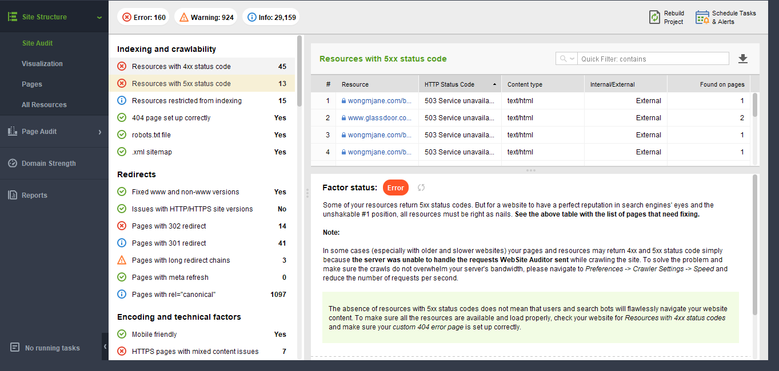
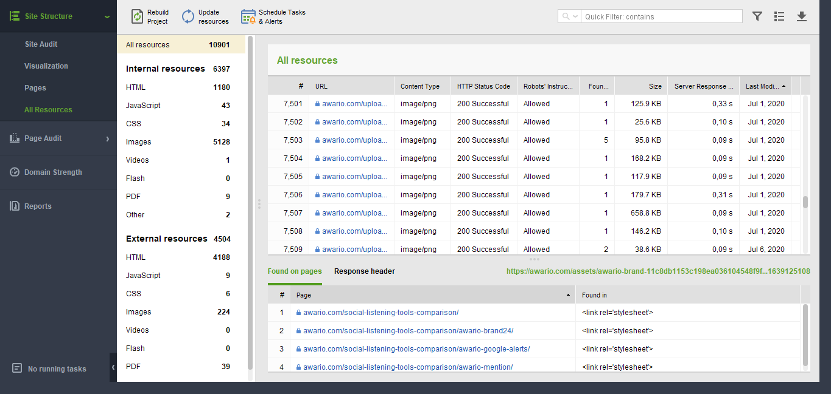
The fully-fledged content optimization module lets you optimize your website pages for any targeted keywords. With WebSite Auditor you can:
- evaluate how your pages are currently optimized;
- calculate the best keyword density for each html element of a page;
- calculate the most appropriate keyword prominence for each html element of a page;
- analyze your top competitors' on-page optimization techniques and develop your own reliable on-page SEO strategy based on them;
- get professional on-page optimization advice and detailed guidance.
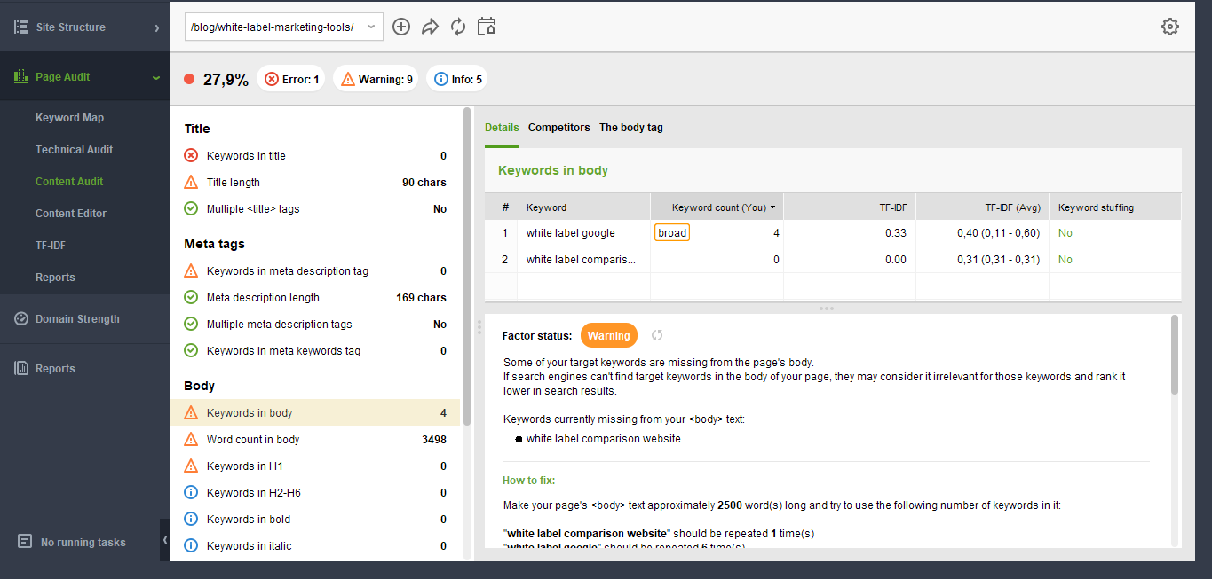
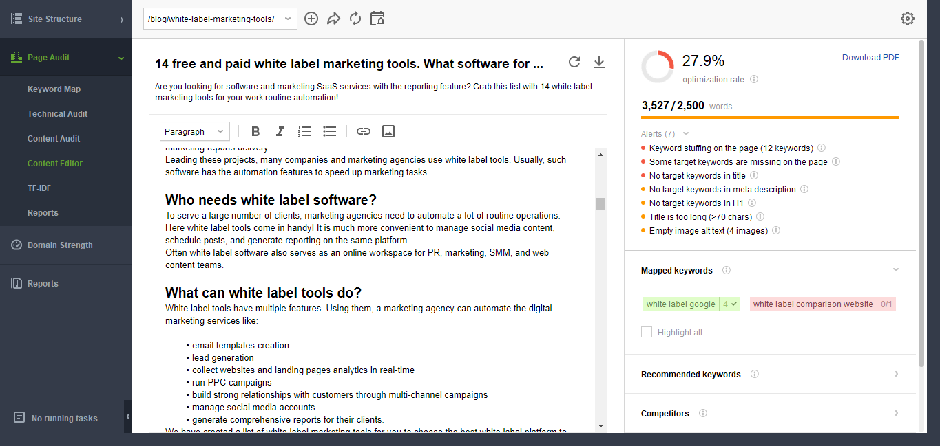
On top of that, WebSite Auditor lets you improve your website crawlability and speed up the process of site indexing by search engines. With the tool you can create and manage robots.txt files and generate .xml sitemaps.
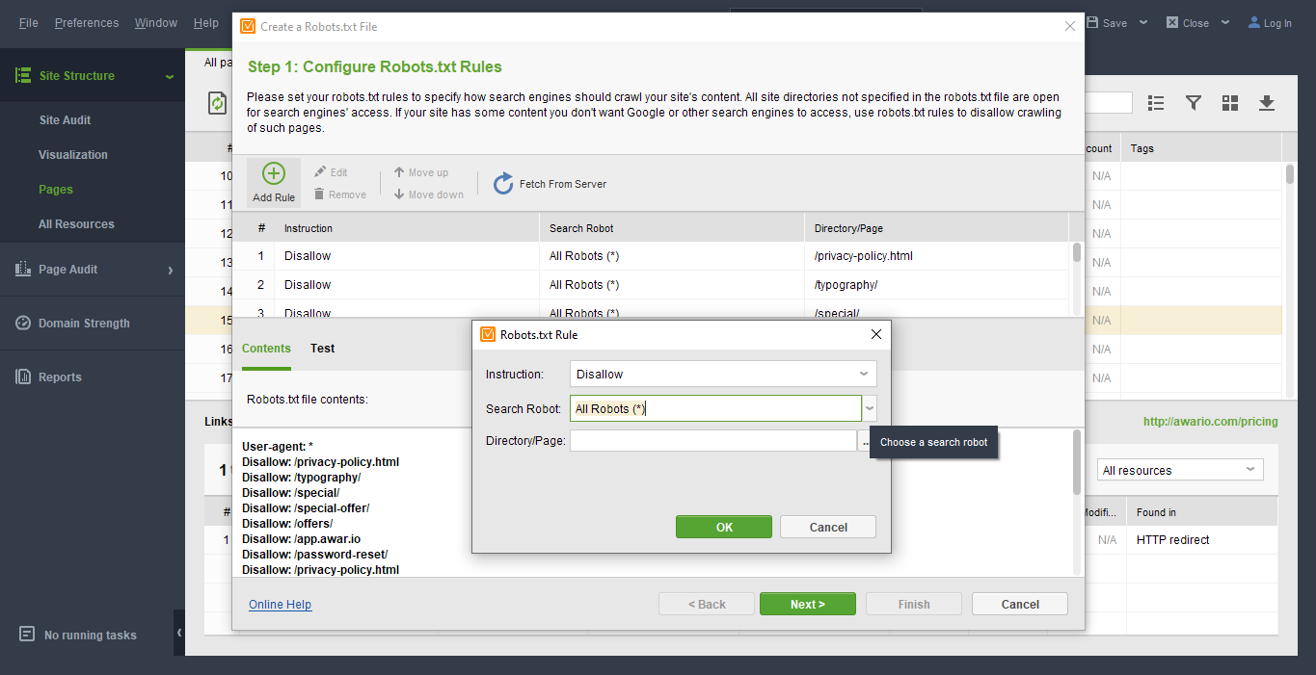
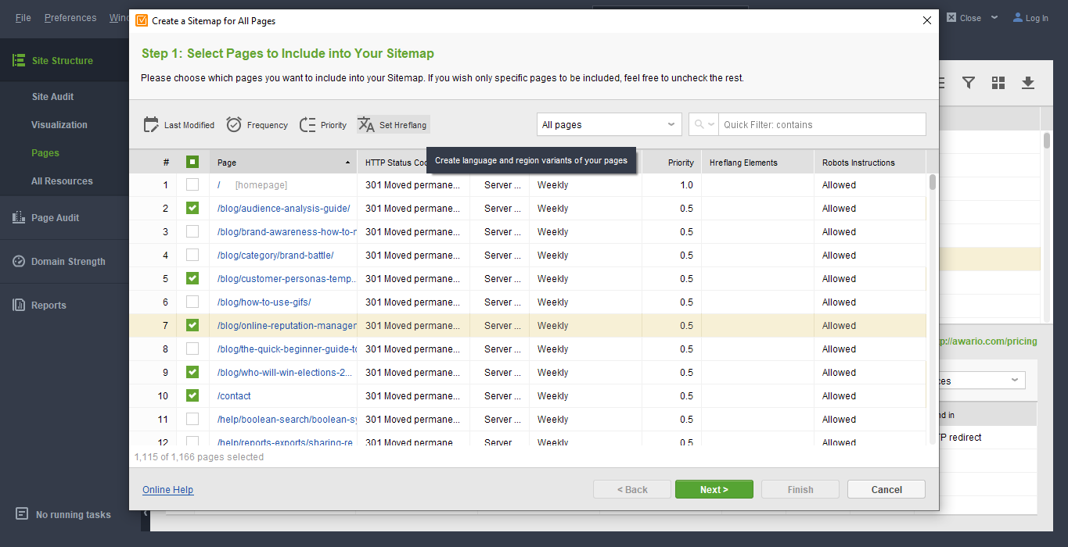

SEO SpyGlass is a backlink checker with a huge database of links
SEO SpyGlass is a powerful competition research and link checking tool. This tool can be used to check your own backlinks, or find links of any website and discover new link sources.
The tool collects backlink data from over 290 international and local search engines and its exclusive 3.6 trillion in-house backlink database. Each found link is analyzed against 40+ important SEO metrics, such as:
- Link Anchor Text
- URL of the backlink page
- Domain and Page InLink Rank
- Domain age
- Link Value
- Visits (taken from Google Analytics);
- and a lot more
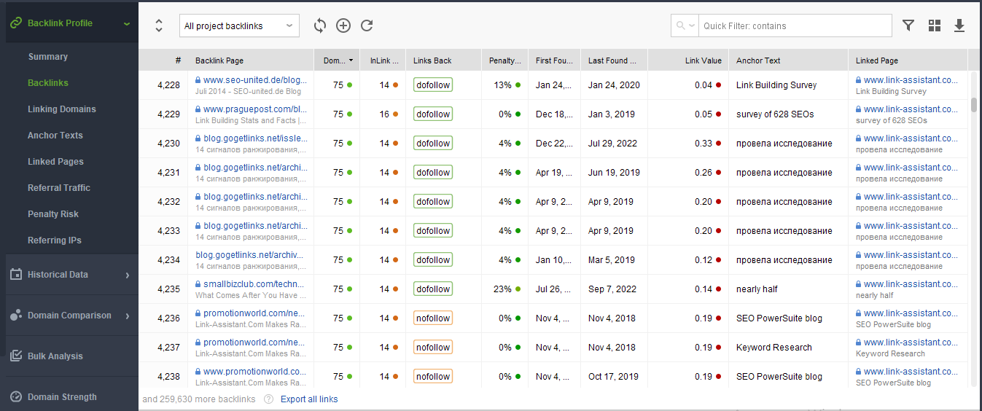

You can also compare link profiles of several sites in one convenient dashboard:
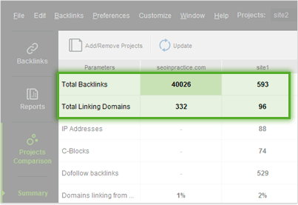
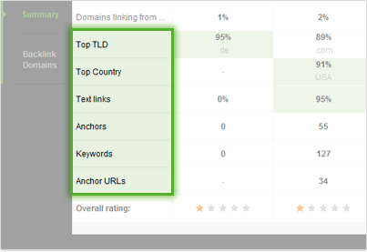

LinkAssistant is the best tool to manage your link building campaigns
Your whole link building campaign can be facilitated by the features of LinkAssistant tool.
With this SEO app you can find a great number of high-quality link sources using various search mechanisms:
- Find sites by keyword search
- Find sites that link to your competitors
- Find sites that already link to you
- Harvest all URLs on webpages you specify
- Perform a deep scan on the website you specify
Each found link is analyzed according to various SEO-important criteria.
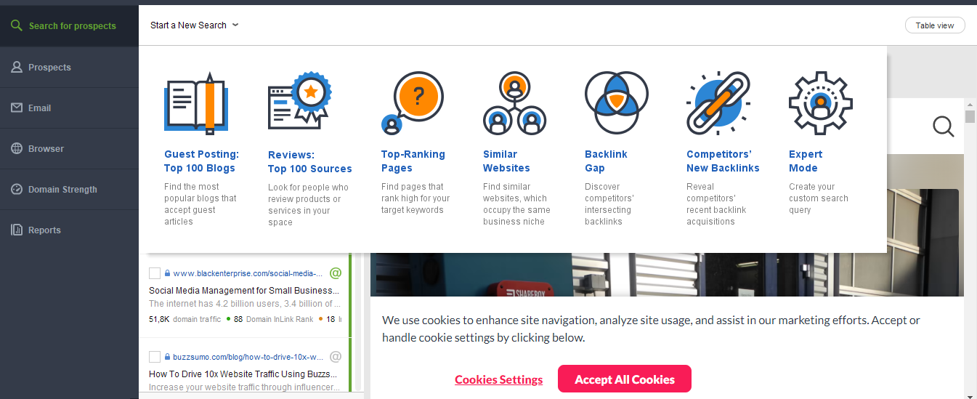

With LinkAssistant you can easily handle large amounts of data: arrange link partners into categories, assign various statuses to them and sort them so that each of your partners is always at hand.
LinkAssistant has a fully-fledged email client that lets you take full control of your link building correspondence. With LinkAssistant you can write personalized e-mails to webmasters and website owners, and never spend more than a couple of seconds to find a way to contact them.
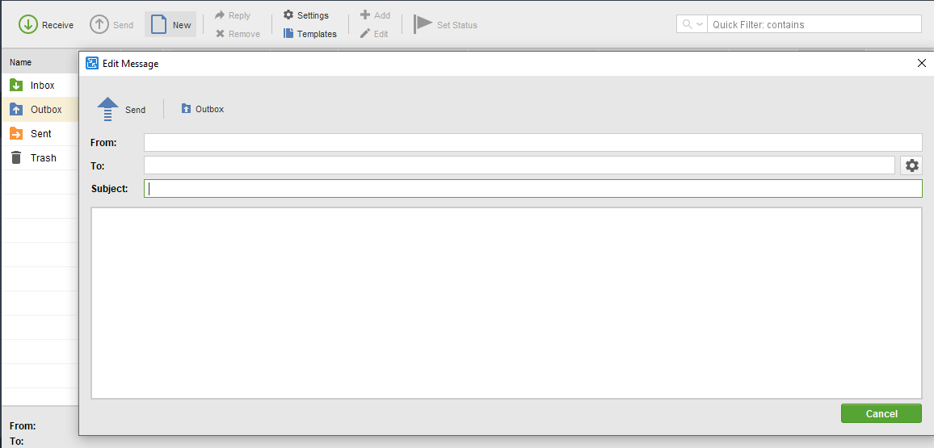

Common features in all SEO PowerSuite tools
Each SEO PowerSuite app has an intuitive reporting tool with a drag-n-drop editor. You can generate professional eye-candy reports, choose which data sections to include and in what order. You can quick-print a report (Professional version), or save it in PDF/HTML format (Enterprise version).
The reports in the Enterprise edition can be whitelabelled. You can remove all mentions of SEO PowerSuite, include your company logo and credentials, adjust color schemes, add client info etc. You can upload SEO PowerSuite reports to your website or email them directly to your clients in PDF or HTML.
Besides PDF/HTML reports, the collected data can be exported "as is" in CSV, TXT, HTML, XML and SQL formats.
All the apps have an intuitive user interface and customizable workspaces, which let process and organize the data the most convenient way.
The software is Windows, Mac OS X and Linux compatible.

Bottom line
SEO PowerSuite software is a leader among SEO tools because it offers:
- all features you need to plan and execute you SEO strategy and check results;
- low fixed price for unlimited data and almost immediate data checks;
- unlimited projects, keywords, backlinks, crawled pages, search engines etc.;
- updates whenever there's a change in SEO techniques to help you adapt to change quickly.
The software comes in three editions, Free (limited features), Professional and Enterprise. You can check the pricing over here.
You can try SEO PowerSuite right now for free.
Or order your copy and start doing SEO with SEO PowerSuite straight away!

