SEO SpyGlass

SEO SpyGlass – backlink checker with billions of links and powerful link quality analytics
SEO SpyGlass is a powerful competition research and link checking tool. So far, this is the least expensive solution to find backlinks pointing to any site, and the only solution with deep link quality research with over 40 factors covered.
SEO SpyGlass can be used to find, analyze and manage your own website's backlinks or to discover the juiciest links your competitors have capitalized on.
For just a tiny fraction of other backlink checkers' price, SEO SpyGlass will let you:
- run core deep analysis of any site's link profile and single out the most attractive links
- segment and sort links for super convenient link management
- compare link profiles of multiple sites to see what links they have in common, and many other factors
Let's look closer at SEO SpyGlass features:

Competition research
The software finds tons of links pointing to a website, retrieving the data from its multi-billion in-house backlink database (over 2.7 trillion backlinks) and over 290 international and local search engines. Each found link is accompanied with various SEO metrics. E.g.:
- Backlink Pages: the exact URLs of the pages linking to your competitor
- Link Anchor Text: lets you see the keywords your competitor is targeting
- Google Page PR; Google Domain PR: shows how valuable the links are in terms of Google PR
- Link Value: determines the value that each backlink may potentially bring to a website
- Domain and Page InLink Rank: estimates the popularity and importance of a domain or a page, a metric close to PageRank
- Backlink IP: lets you see all links coming from the same domains, or analyzes what countries most backlinks are coming from
Also, SEO SpyGlass lets you:
- Discover your competitors' links that come from social media sites (Facebook, Twitter, Delicious, Stumble Upon, Diigo etc.), see the exact value of those backlinks and how much each link contributes to the site's PageRank
- Know the age of every backlink domain, to analyze how reputable it is for search engines
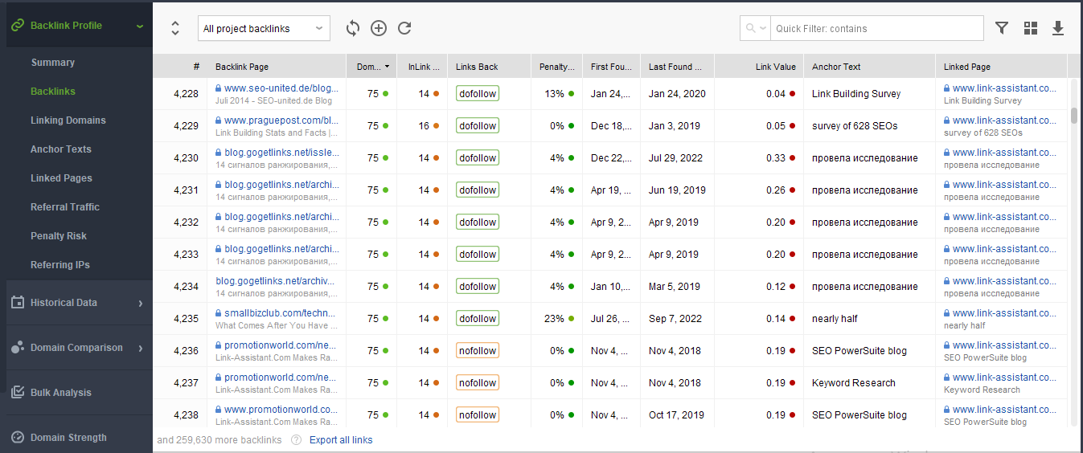
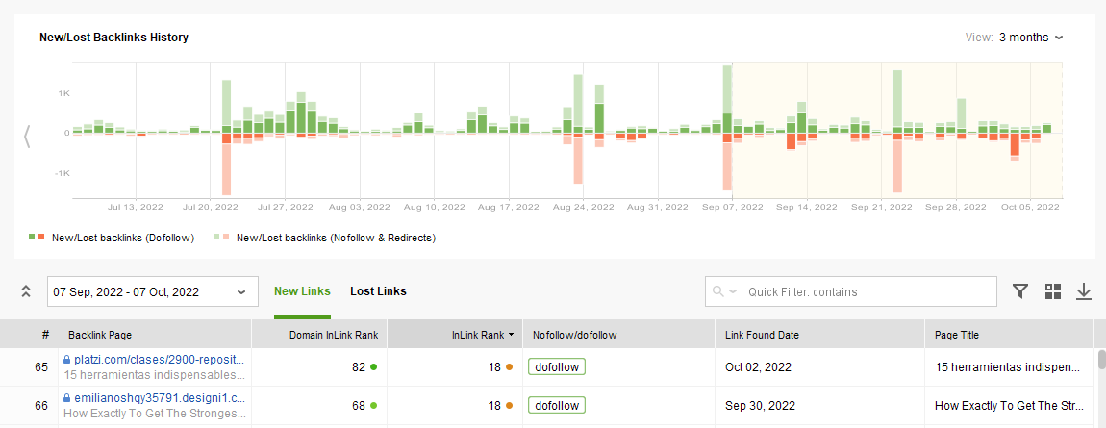
Moreover, SEO SpyGlass lets you compare links of up to 5 websites within one convenient working area, thus letting you check your competitors' backlink profiles at a glance.

Link Verification and Traffic monitoring
SEO SpyGlass lets you monitor and verify all your existing backlinks to keep track of how your link-building campaign is progressing.
Also the application lets you instantly fetch ‘Visits' stats from Google Analytics, so you can view the exact number of visitors a specific backlink brings. With this feature, you get the full pattern of the backlinks that work best for your biz niche in terms of traffic.
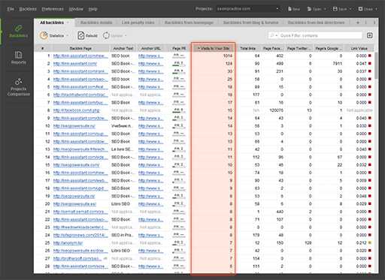

Reporting facilities and data export
SEO SpyGlass offers an easy way to create PDF or HTML reports that will suit your business needs. The tool features a drag-n-drop report editor which makes it easy for you to choose which data sections to include in the report and how to order them.
You can also customize the way reports look, and whitelabel them if necessary (you can change reports' color schemes, language, add your own or your customers logo, fill in your firm's or your clients requisites etc). You can simply print a report, or save it as a PDF/HTML file and, if needed, upload it to the web or send to email, straight from the software.
If you prefer to work with the data further outside SEO SpyGlass (ex. in an Excel spreadsheet), you can export the data in various supported formats (.csv,. xml, .sql, .txt).
SEO SpyGlass is Windows, Mac and Linux compatible.

Bottom line
SEO Spyglass is a cost-effective backlink checker with deep informative link profile analysis and powerful link management. When you need not just a big list of links, but a good understanding of where they can take you, SEO SpyGlass is definitely the best choice among backlink software.
The price varies as the tool comes in three editions: Free (with certain limitations), Professional and Enterprise. You can purchase it as one tool, or as part of the SEO PowerSuite toolkit which also includes the tools for rank checking, keyword research, link building and on-page SEO. You will find SEO SpyGlass pricing here.
Get your hands on the most effective link checking tool on the market!
Download your free copy of SEO SpyGlass

