WebSite Auditor

WebSite Auditor is a full-fledged on-page optimization tool
WebSite Auditor is an on-page SEO tool that is made to help you identify and fix all site errors, and make sure every landing page is optimized for the keywords you target.
This software not only crawls all your site's pages to run a thorough check, it also analyzes top ranking competitors in your niche and uncovers their keyword usage techniques that have led them to top rankings.

WebSite Auditor helps you find and fix all on-page issues that may affect your rankings:
- Find all technical issues that lower your rankings
- Learn how to fix the problems
- See how your competitors are handling on-page SEO
- Get keyword usage advice for each of your pages
Let's see in more detail how WebSite Auditor covers two major on-page optimization stages:
- SEO Site Audit
- Content Optimization

SEO Site Audit
Before starting on-page SEO process, we should carefully check our website against various SEO factors. A site should be evaluated in terms of navigation, robustness of its structural elements, W3C compliance, user- and search engine-friendliness. With Google's new policy on mobile-friendly sites in place, websites must also be able to pass the mobile friendliness test. WebSite Auditor covers all this.
WebSite Auditor crawls your entire site (or any site you need to research, ex. a competitor) and reports on a variety of on-page SEO factors that are important for successful ranking. So the tool runs all-rounded SEO audit and brings to the spotlight any website's structure and coding flaws. The software lets you find and fix:
- Broken links
- Duplicate content
- Validation errors (W3S markup validator)
- 404 and other server response code errors
- Not indexed webpages
- Missing or too long titles and meta description
The application also lets you fetch info on:
- The total number of links on the page
- The number of external links on the page
- Google PageRank of any page
- Cache date in Google, Yahoo!, Bing
- The amount of traffic each of your pages gets
- And more!
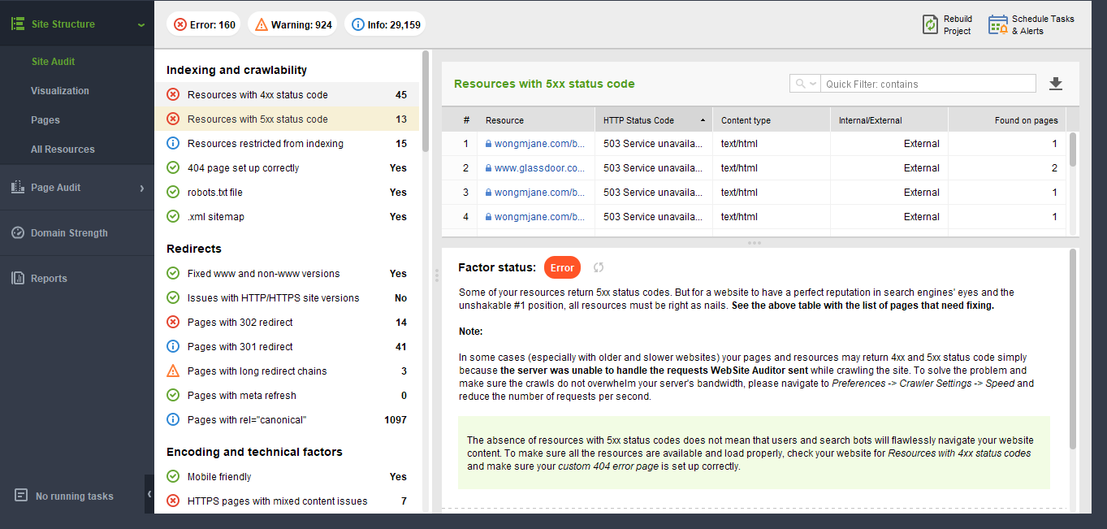
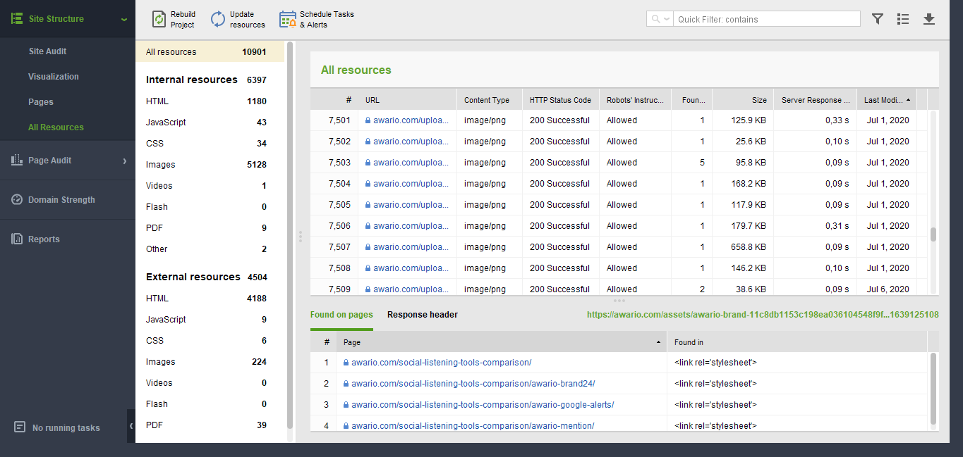

Content Optimization
WebSite Auditor lets you optimize each page for any targeted keyword in over 400 search engines. With the software you will be able to:
- Analyze the best optimization techniques of your competitors and develop your own sure-fire strategy on the basis of their battle-tested SEO experience;
- Evaluate how your landing pages are optimized at the moment;
- Optimize your pages' content for any keywords in any languages;
- Calculate the appropriate keyword density for each html element of your landing page;
- Calculate the appropriate keyword prominence for each html element of your landing page;
- Get professional on-page optimization advice and the detailed guidance in plain English
- and a lot more

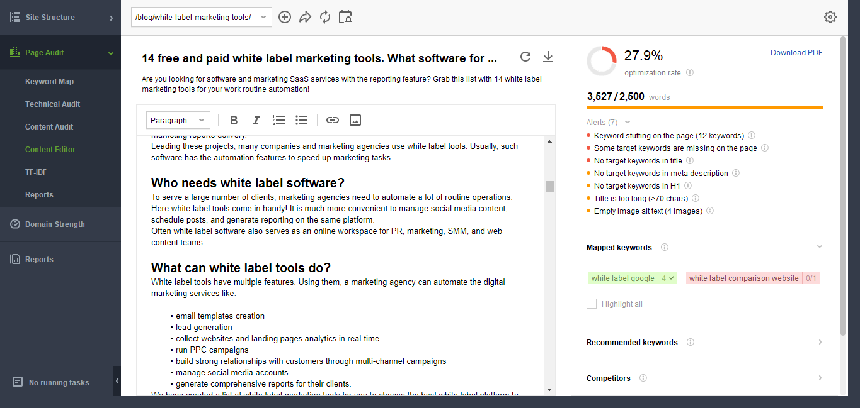
The tool offers you a mobile friendliness check to see whether your pages comply with Google's recent mobile friendly algo change.
On top of all that, the software lets you create and manage your robots.txt file and the .xml sitemap (and upload them to your website straight from the software).

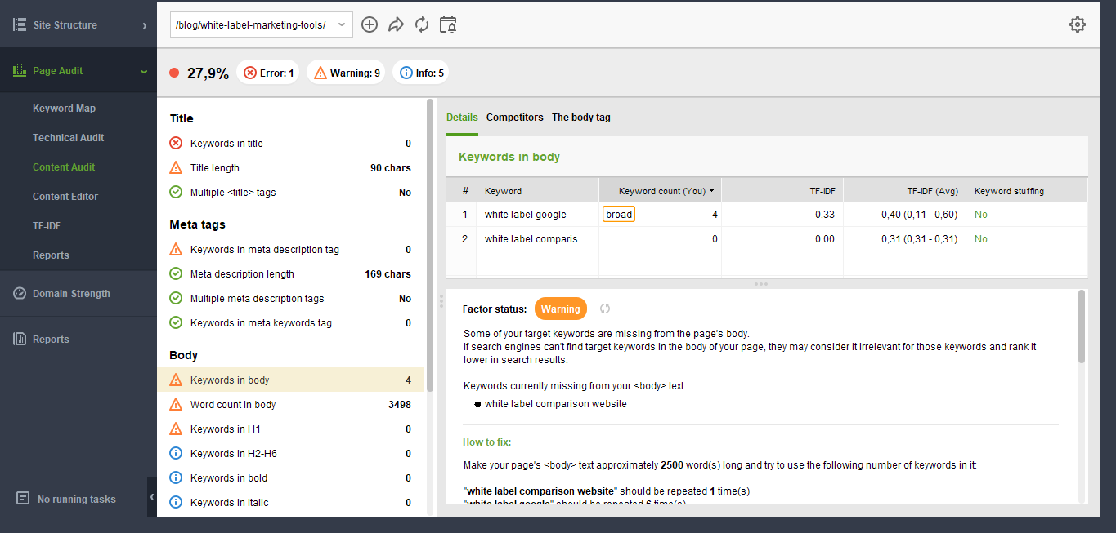

Reporting facilities and data export
WebSite Auditor lets you use its new drag-and-drop report editor to create on-page SEO reports that include exactly the data you need. Besides being able to choose and organize different report sections, you can customize the report even further - change its color scheme, upload your company logo, add your company credentials (or add your client's logo and credentials).
You can simply print a report, or save it as a PDF/HTML file and, if needed, upload it to the web or send to email, straight from the software.
If you prefer to work with the data further outside WebSite Auditor (ex. in an Excel spreadsheet), you can export the data in various supported formats (.csv,. xml, .sql, .txt).

Bottom line
WebSite Auditor is an advanced onpage optimization tool that saves you tons of valuable time and arms you with detailed recommendations on how to improve your website's results in Search Engines.
The software is cross-platform, so it will seamlessly run on Windows, Mac and Linux.
The price varies as the tool comes in three editions: Free (with some limitations), Professional and Enterprise. You can purchase WebSite Auditor as a standalone tool, or as part of the SEO PowerSuite toolkit which also includes the tools for rank checking, keyword research, link analysis and link building. You will find WebSite Auditor pricing here.
You can check it out for free and see how deeply you can check your site and how many things you might have been missing.
Click here to download the free edition of WebSite Auditor

